**COMMODITY PRICES PROTOTYPE REPORT**

INTRODUCTION

The commodity price system is part of a larger system aimed at aiding farmers and their businesses with accurate information concerning their various products on the market. The system will thrive to engage key stake holders in the business in a collaborative manner, where venders will be able to submit prices of various production from various locations. This in turn will help both the buys and sellers to have prior information before going to buy or sale their farm products in various locations, as they will be able to know the right time to take their products to the market places.

System Design

Login/ Sign up

The downloaded application of commodity price on a mobile device will have to be successfully activated by clicking on the application’s icon on the mobile device’s screen as seen below in figure 1.

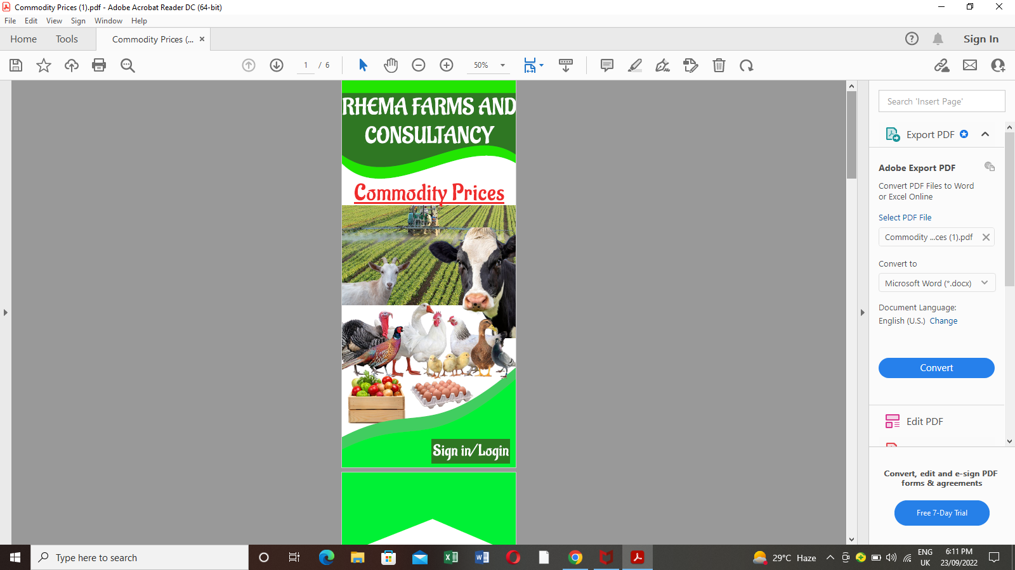*(Figure 1)*

After the successful activation, the application will require the user to sign up for the first time attempt of use, for registration purposes and to Login for the usual users for authentication purposes as seen in the diagram below.(figure 2)

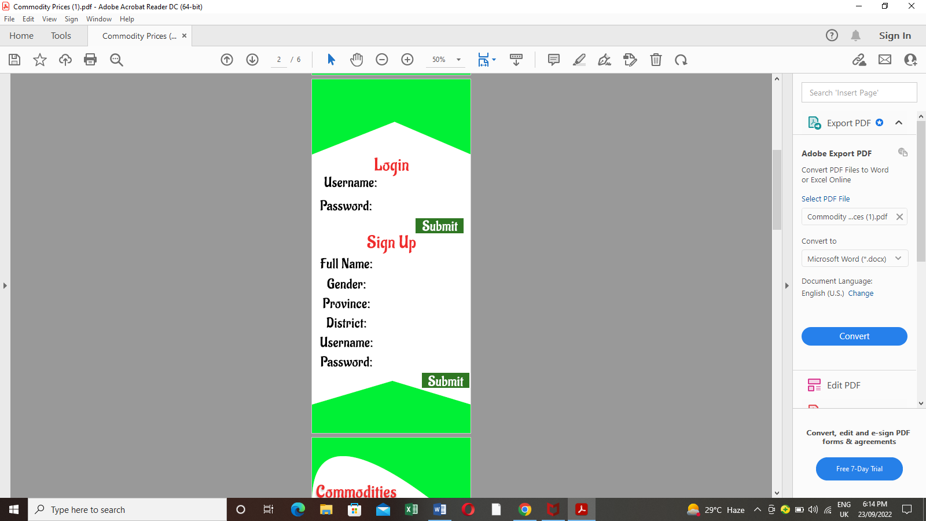(Figure 2)

Upon successfully signing up or Logging in, a landing page or home page will appear where the user will choose the desired product by selecting a link from the categorized list provided as seen in figure 3.

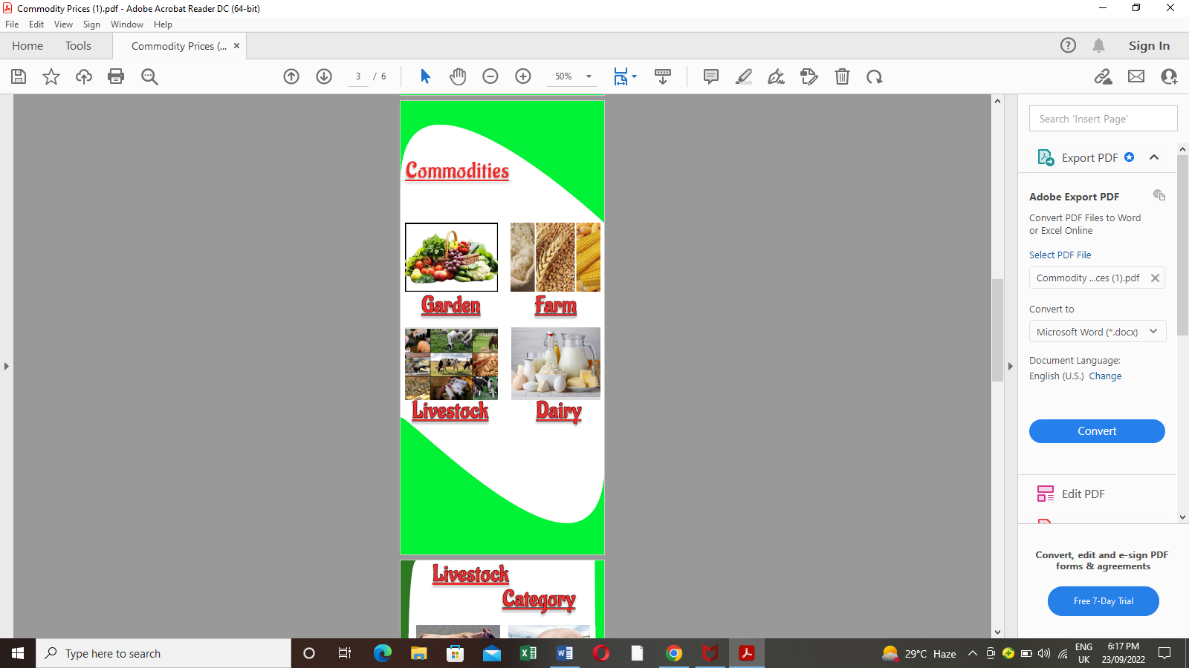(Figure 3)

After selecting the product category, the categories will appear which will give the user further options to choose the actual product there are interested in as seen below in figure 4.

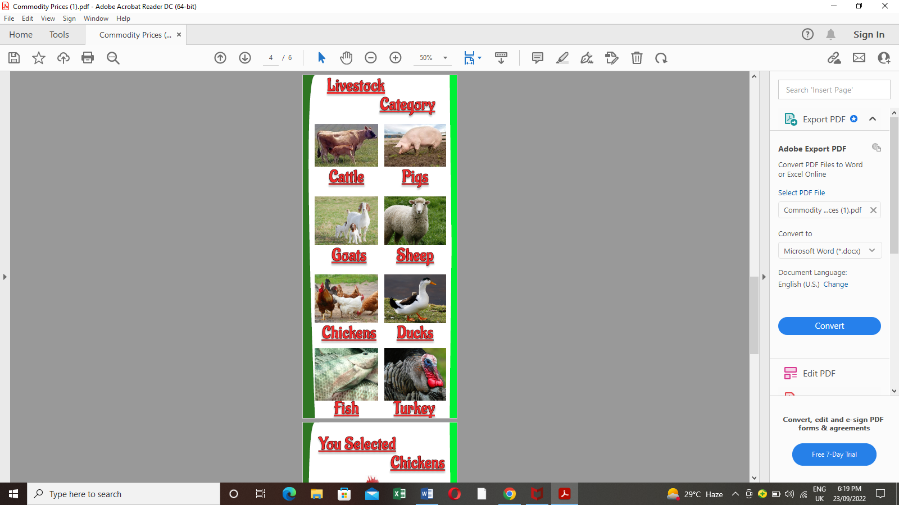(Figure 4).

After a successful selection of the product of interest in figure 4, a page will appear which will reguire the user to check for the price by inputing data of the province and disctrict of interest and the specific type of product and submitting the data using the corresponding button. The price will appear next to the product picture in real time without refreshing the page. (See figure 5)

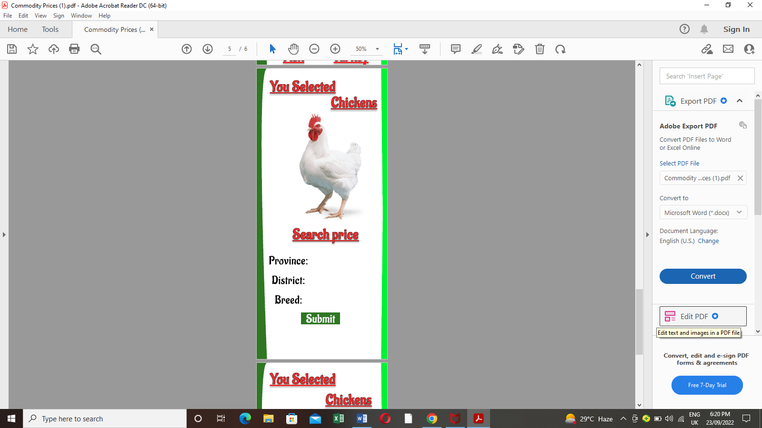(Figure 5).

The application will allow the venders from various market places to submit the data in the system as they are the primary sources of information for the system. They input data such as the province and district they are trading from and the prices their products are costing at that particular time as seen below in Figure 6.

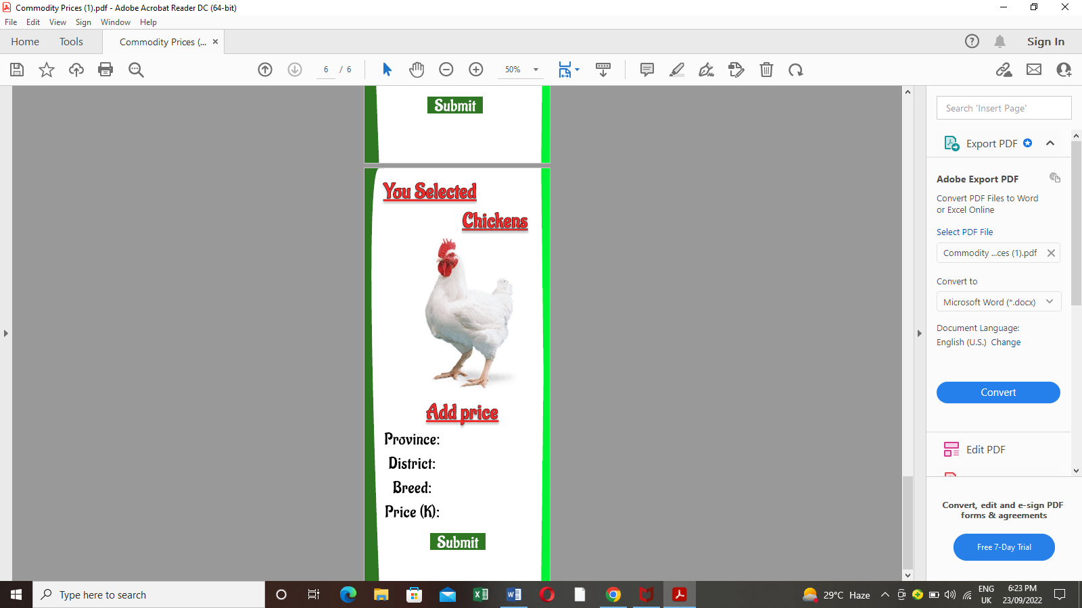(Figure 6).

CONCLUSION

This prototype is just part of the bigger system. The features which have been presented above are just examples of the many features the system will have. The system design will be so efficient such that just by clicking a button, the required information will be given out on just a portion of the page and thereby having no need to refresh the page.

Web system Content

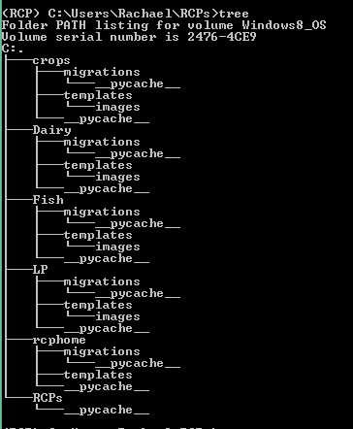

LP=llivestock & poultry products module

Rcphome=web system homepage

Fish=fish products module

Crops=crop products module

Dairy=dairy products module

HOME PAGE

The page allows users to view products such as; Crop, Dairy, Fish, Livestock and Poultry.

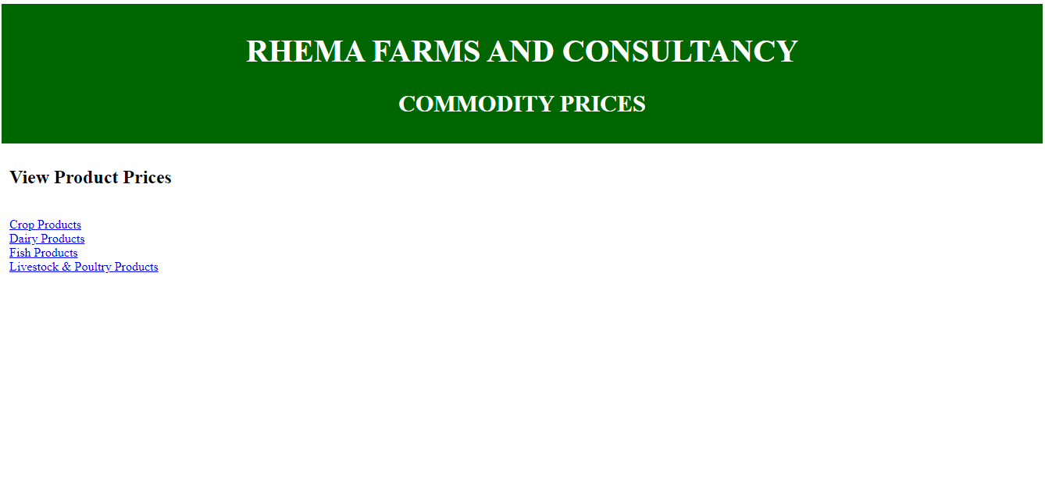

Database showing Crop products’ Category, Name, Unit(kg), Price, District and Province they are trading from.

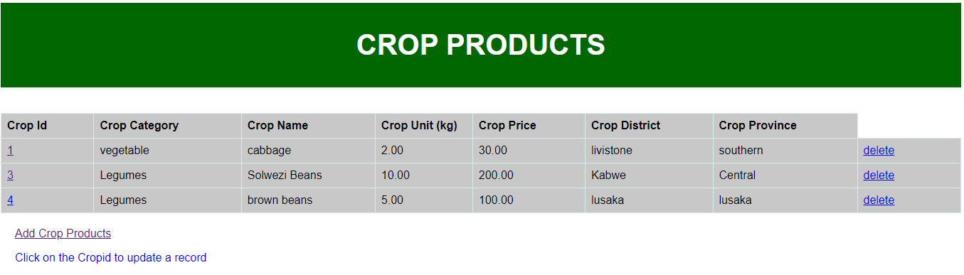

**CODE FOR VIEWING CROP PRODUCTS**

Here is the code functionality for the viewing of crop product page;

<style>

/* Style the header */

header {

background-color: #006600;

padding: 10px;

text-align: center;

font-size: 20px;

color: white;

}

/* Style the footer */

footer {

background-color: #777;

padding: 20px;

text-align: center;

color: white;

}

table {

font-family: arial, sans-serif;

border-collapse: collapse;

width: 100%;

padding: 20px;

margin-left: auto;

margin-right: auto;

}

th {

border: 1px solid #D6EEEE;

text-align: left;

padding: 8px;

width:40px;

}

td {

border: 1px solid #D6EEEE;

text-align: left;

padding: 8px;

width:40px;

}

tr {

background-color: #c8c8c8;

}

</style>

<header>

<h1>CROP PRODUCTS</h1>

</header>

<br><br>

<table>

<tr>

<th>Crop Id</th>

<th>Crop Category</th>

<th>Crop Name</th>

<th>Crop Unit (kg)</th>

<th>Crop Price</th>

<th>Crop District</th>

<th>Crop Province</th>

</tr>

{% for x in mycrops %}

<tr>

<td><a href="cropsupdate/{{x.id }}">{{ x.id }}</a></td>

<td>{{ x.crop_category }}</td>

<td>{{ x.crop_name }}</td>

<td>{{ x.crop_unit }}</td>

<td>{{ x.crop_price }}</td>

<td>{{ x.crop_district }}</td>

<td>{{ x.crop_province }}</td>

<td><a href="delete/{{ x.id }}">delete</a></td>

</tr>

{% endfor %}

</table>

<nav>

<a href="addcrops/">Add Crop Products</a><br>

<p> Click on the Cropid to update a record</p>

</nav>

This is a page or form where data about crop products is added to the database. The code functionality for this form is shown below.

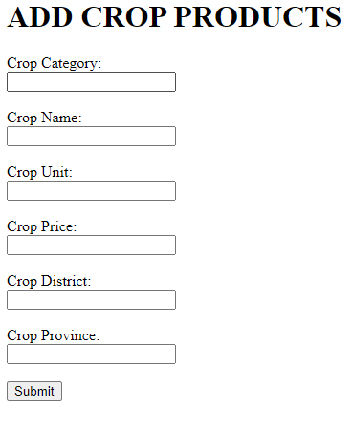

<h1>ADD CROP PRODUCTS</h1>

<form action="addrecord/" method="post">

{% csrf_token %}

Crop Category:<br>

<input name="cropcategory">

<br><br>

Crop Name:<br>

<input name="cropname">

<br><br>

Crop Unit:<br>

<input name="cropunit">

<br><br>

Crop Price:<br>

<input name="cropprice">

<br><br>

Crop District:<br>

<input name="cropdistrict">

<br><br>

Crop Province:<br>

<input name="cropprovince">

<br><br>

<input type="submit" value="Submit">

</form>

This is a page or form where data about crop products updates being made to the database. The code functionality for this is shown below.

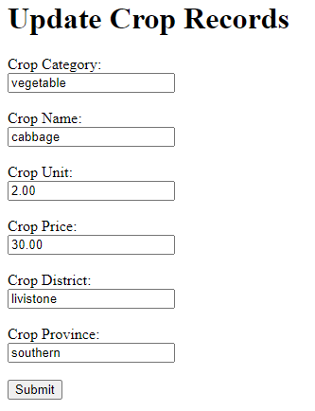

<h1>Update Crop Records</h1>

<form action="updaterecord/{{ mycrops.id }}" method="post">

{% csrf_token %}

Crop Category:<br>

<input name="cropcategory" value="{{ mycrops.crop_category }}">

<br><br>

Crop Name:<br>

<input name="cropname" value="{{ mycrops.crop_name }}">

<br><br>

Crop Unit:<br>

<input name="cropunit" value="{{ mycrops.crop_unit }}">

<br><br>

Crop Price:<br>

<input name="cropprice" value="{{ mycrops.crop_price }}">

<br><br>

Crop District:<br>

<input name="cropdistrict" value="{{ mycrops.crop_district }}">

<br><br>

Crop Province:<br>

<input name="cropprovince" value="{{ mycrops.crop_province }}">

<br><br>

<input type="submit" value="Submit">

</form>

Database showing Dairy products’ Id, Name, Unit(L), Price, District and Province they are trading from.

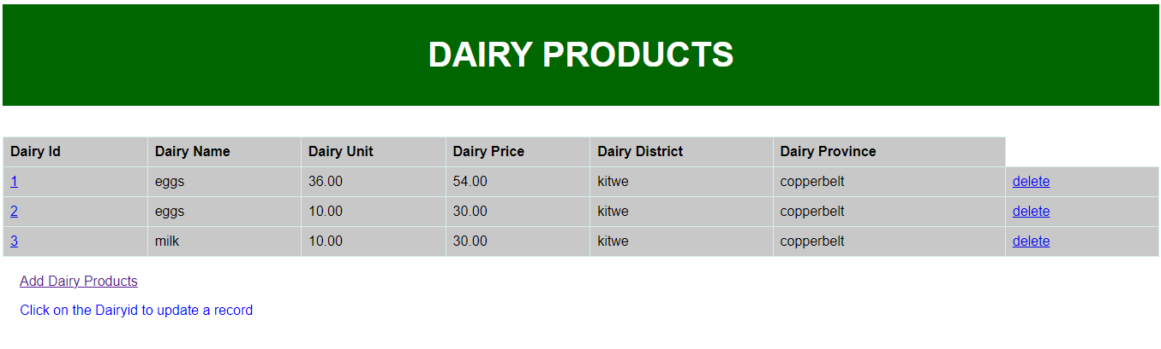

This is where necessary information about Dairy products are added to the database.

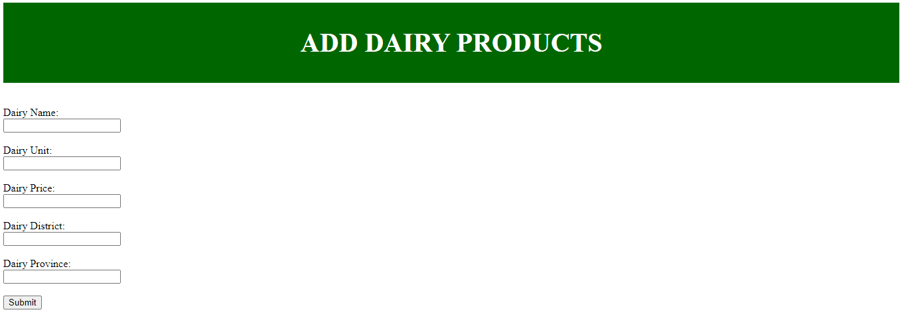

This is a page or form where data about dairy products is updated to the database.

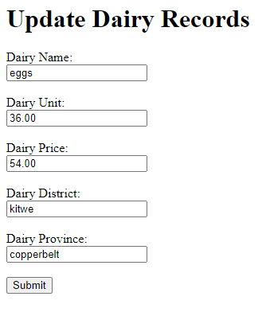

Database showing Fish products’ Id, Name, Unit(kg), Price, District and Province they are trading from.

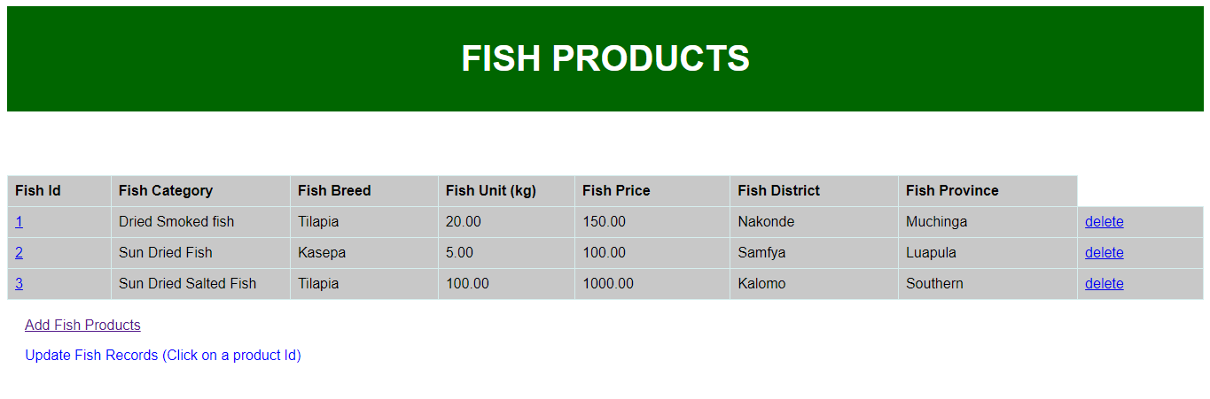

This is where necessary information about Fish products are added to the database.

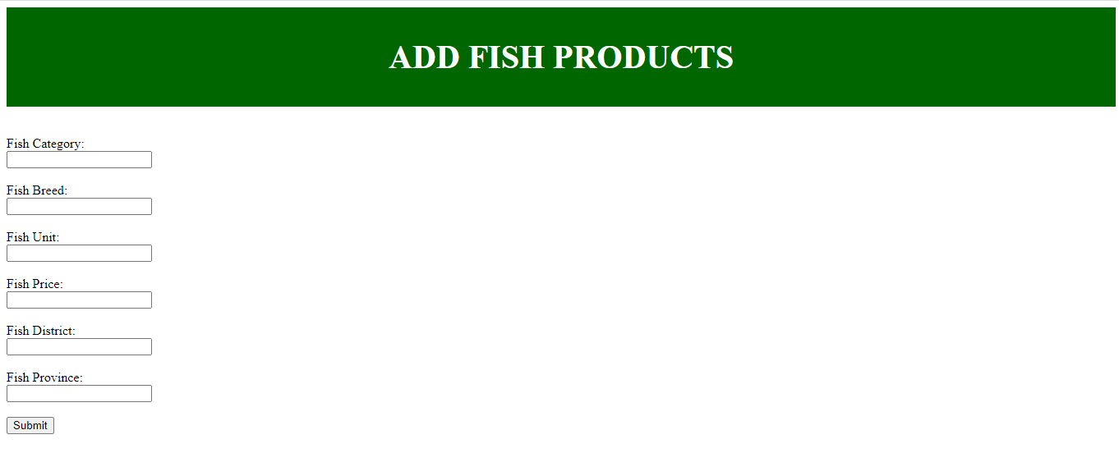

This is a page or form where data about Fish products is updated to the database.

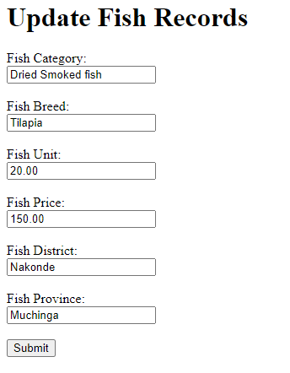

Database showing Livestock and Poultry products’ Id, Name, Unit(L), Price, District and Province they are trading from.

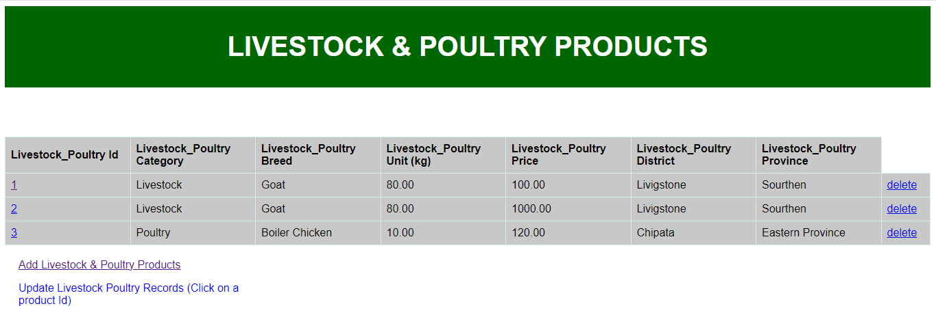

This is where necessary information about Livestock and Poultry products are added to the database.

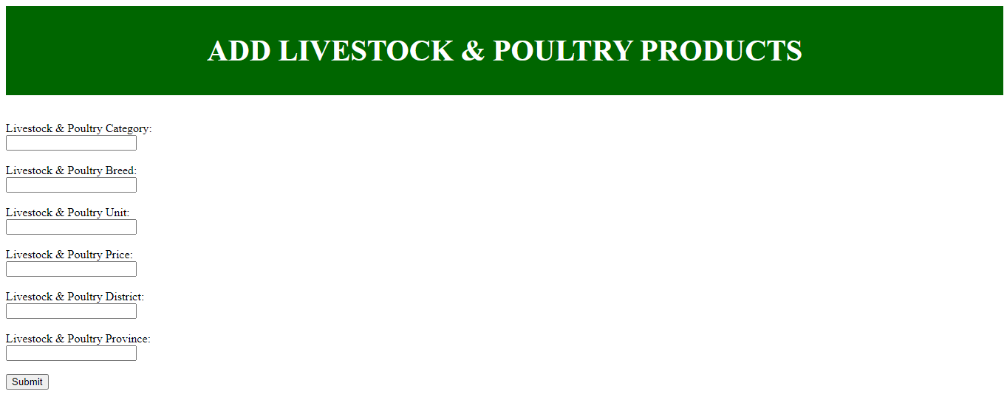

This is a page or form where data about Livestock and Poultry products is updated to the database.

